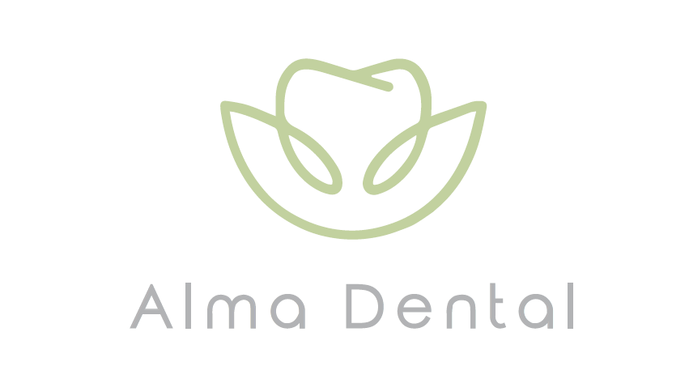

Alma Dental Practice
PRIVACY POLICY FOR PATIENT DATA

This Privacy Notice is a shortened form of our Privacy Policy and any patient who wishes to have a copy of our full Policy should ask Amanda Whyatt who is the practice Data Protection Officer.

The practice Data Controller is Roshan Singh.

Personal data held for our patients
- Name, address, date of birth.
- Unique identification number.
- Next of kin.
- Email address.
- Phone numbers.
- GP contact details.
- Occupation.
- Medical history.
- Dental care records.
- Photographs.
- Family group.
- Membership plan details.
- Financial information.
- Credit cards receipts.
- Correspondence.
- Details of any complaints received.

We keep an inventory of personal data we hold on our patients and this is available on request.

Why do we need to hold this information on you?

- To provide appropriate, safe, and effective dental care and advice for you.
- To fulfil any contracts we hold in relation to your care.
- For business administration of your care.

Disclosure to third parties

We will share our patients’ personal information with third parties when required by law, to enable us to deliver a service to them, or where we have another legitimate reason for doing so. Third parties we may share patients’ personal information with may include:

- Regulatory authorities such as the General Dental Council and the National Health and Social Care regulators.
- NHS Local Authorities
- Dental payment plan administrators
- Insurance companies
- Loss assessors
- Fraud prevention agencies
- In the event of a possible sale of the practice at some time in the future.

We may also share personal information where we consider it to be in a patient’s best interest or if we have reason to believe an individual may be at risk of harm or abuse.

Legal basis for processing data held about patients

- The legal basis on which we process personal information for our private patients is ‘legal obligation.’
- The legal basis on which we process personal information for our payment plan patients is ‘contract.’
- The legal basis on which we process personal information for our NHS patients is ‘legal obligation.’

Retention period

This practice retains dental records and orthodontic study models while you are a patient of our practice and after you cease to be a patient for at least eleven years or for children until age 25, whichever is longer.

Complaints

You have a right to complain about how we process your personal data. All complaints concerning personal data should be made in person or in writing to Amanda Whyatt. All complaints will be dealt with in line with the practice complaints policy and procedures.

If you are unhappy with the resolution of your complaint, you have the right to raise your complaint with the Information Commissioner’s Office (ICO).

The ICO can be contacted at https://ico.org.uk/make-a-complaint, via or call the ICO helpline on 0303 123 1113.live chat or via the ICO helpline on 0303 123 1113.

Further information on making a complaint to the ICO can be found here: https://ico.org.uk/make-a-complaint/data-protection-complaints/data-protection-complaints

This Privacy Notice was reviewed and implemented on 30/10/2024.

It will be reviewed annually and is due for review on 30/10/2024 or prior to this date in accordance with new guidance or legislative changes.

Document Change Record
for
Privacy Notice for Patient Data

The table below is used to register all changes to the policy:

Published Date | Document Version Number | Pages affected | Description of revision | Author
01.02.2021 | v3.0 | Page 1 | Notes on obtaining evidence of opt-in consent. | PL
01.02.2021 | v3.0 | Page 3 | Information on when the National Opt-out Policy would apply in dental practice. | PL
24.01.2023 | v3.1 | Pages 2, 5 & 6 | Update GDPR references and retention of dental records. | PP
09.08.2023 | v3.2 | Page 5 | Updated the complaints section with contact details for the ICO. | PL
14.08.2023 | v3.3 | Page 5 | Updated retention period for patient records. | PL
15.08.2023 | v3.4 | Page 3 | Amalgamation of English & Welsh policy and renamed. | IL
09.02.2024 | v3.5 | Whole document | The whole document has been reviewed to satisfy the criteria of a notice; previous versions of our Privacy Notice have replicated the Privacy Policy. This notice is relevant to all the home nations. | IL

